

Trinity International College

(Under the affiliation of Tribhuvan University)

Dillibazar, Kathmandu, Nepal

**LAB ASSIGNMENT I**

**FINANCIAL ACCOUNTING**

Submitted to:

Sharmila Bhattarai

Department of Computer Science and Information Technology

By: **NAYAN TANDUKAR**

Roll No: 09

Id no: 26167

Semester: Second

Batch:2078

**Accounting**

Accounting is an act of recording, analyzing, interpreting, reporting and communicating the recorded data or transactions which have monetary value in a systematic way to interested individuals and organizations. Accounting helps to find out profit and loss and financial position about the business. It helps to provide necessary information to the various users. Accounting is also often called as the language of business because the purpose of accounting is to communicate or report the results of business operations and its various aspects to various users of accounting information.

**Objectives of Accounting**

* To maintain the record of financial transactions in a systematic way
* To ascertain the operating result (profit and loss) of business organization
* To provide financial position of the business organization
* To help in determining tax liabilities
* To help protect the property
* To provide financial information to the management for decision making and planning

**Basic concepts of Accounting**

* **Business transactions:** A business transaction is “The movement of money’s worth from one person to another.” or exchange of values between two parties’ id also known as “Business transaction.”
* **Purchase:** A purchase means goods purchase by the businessman from a supplier.
* **Sales:** Sales is a goods sold by the businessman to his customers.
* **Purchase Return or Outward Invoice:** Purchase return means the return of the full or a part of goods purchased by the business to his suppliers.
* **Sales Return or Inward Invoice:** Sales return means the return of the full or a part of the goods sold by the customers to the business.
* **Assets:** Assets are the things and properties possessed by the businessman not for resole but for the use in the business.
* **Liabilities:** All the amount payable by a business concern to outsiders are called liabilities.
* **Capital:** Capital is the amount invested for starting a business by a person.
* **Debtors:** Debtor is the persons who owed amount to the businessman.
* **Creditors:** Creditor is the person to whom amounts are owed by the businessman.
* **Debit:** The receiving aspect of the business transaction is called debit or Dr.
* **Credit:** The giving aspect of the business transaction is called debit or Cr.
* **Drawing:** Drawings are the amount withdrawn (taken back) by the businessman from his business for his personal or private and domestic purpose. Drawing may be made in the form of cash, goods and assets of the business.
* **Receipts:** It is a document issued by the receiver of cash to the giver of cash acknowledging the cash received vouchers.
* **Ledger:** The book of final entry where account lie.
* **Journal Entries:** The daily record of the transactions.
* **Trial balance:** It is a statement of all the ledger account balance prepared at the end of particular period of verifying the accuracy of the entries made in the book of accounts.
* **Profit and Loss account:** It is prepared to ascertain actual profit or loss of the business.
* **Balance Sheet:** To ascertains the financial positions of the business. It is a statement of assets and liabilities.

**Types of Account:**

1. **Personal Account:** Personal Accounts are the account of person, firms, concerns institutions which the business deal.

**Principle: Debit** the receiver. **Credit** the giver.

1. **Real Account:** Real Accounts are the account of things, materials, assets & properties. It has physical existence which can be seen & touch. EX: Cash, Sale, Purchase, Furniture, Inventories, etc.

**Principle: Debit** what comes in? **Credit** what goes out?

1. **Nominal Account:** Nominal Accounts are the account of service received (expenses and losses) and service given (income and gain). EX: Salary, Rent, Wages, Stationery, etc.

**Principle: Debit** all the expenses and losses.  **Credit** all the income and profit.

**Introduction of Tally:**

Tally is powerful accounting software, which is driven by a technology called concurrent multi-lingual accelerated technology engine. It is easy to use software and is designed to simply complex day to day activities associated in an enterprise. Tally provides comprehensive solution around accounting principles, inventory and data integrity. Tally also has feature encompassing global business.

Tally software comes with easy-to-use interface thus making it operationally simple. Tally accounting software provides a solution around inventory management, stock management, invoicing, purchase order management, discounting, stock valuation methodology, etc. Tally accounting software also comes with drill down options, which can track every detail of transaction. It helps in maintaining simple classification of accounts, general ledger, accounts receivable and payable, bank reconciliation, etc. The technology employed by tally makes data reliable and secure. Tally software supports all the major types of file transfer protocols. This helps in connecting files across multiple office locations. Tally accounting software is capable of undertaking financial analysis and financial management. It provides information around receivables turnover, cash flow statement, activity consolidation and even branch accounting.

**Objective:** The main objective of Tally is to introduce the students to the basics of Accounts and the usage of Tally for accounting purpose. It teaches student to maintain accounts with and without inventory.

**HOW TO USE TALLY?**

**Getting started with tally:** We need to install the Tally ERP 9 properly on our computer. Click on the icon and open Tally to work in it.

**Creating a company:** This function helps us to make a company in tally. Many companies can be made and saved in tally through company creation.

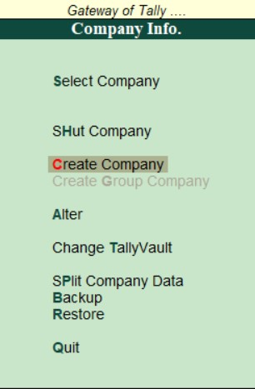

* Go to Gateway of Tally.
* In Company info we can see Create Company. Select it, Company creation window will appear.
* At last, the message Accept? Yes/ No will be displayed.
* Press Enter or Y to save the details.
* To create next company, user can repeat the procedure from of tally.

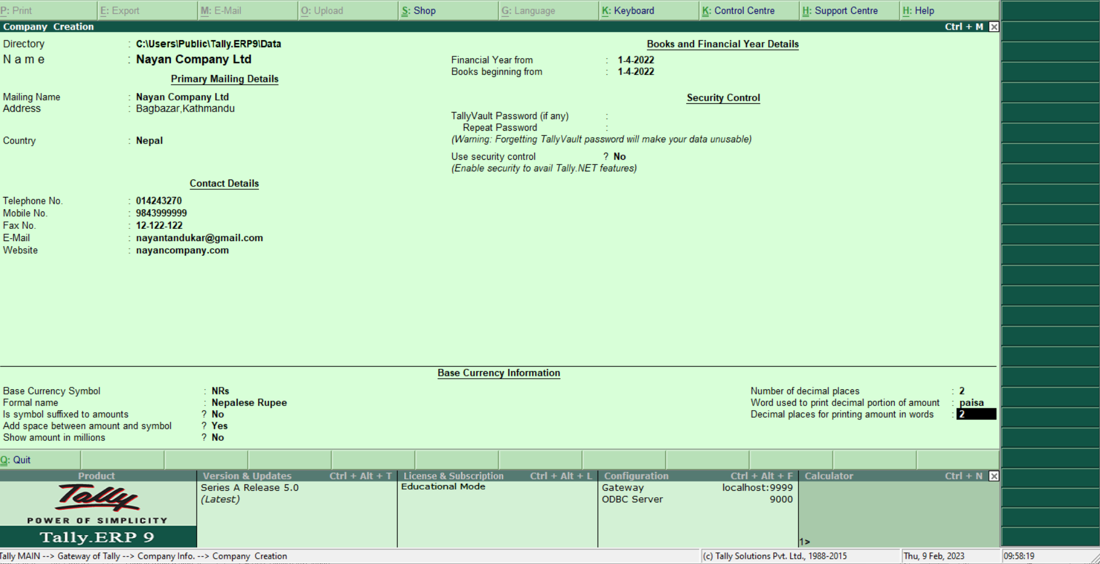

**Select Company:** We can select a company from many created companies.

* Go to gateway of tally. Press Alt+F3 keys in keyboard. Select the option select company in company info and enter. Select company allows you to load another company from lift of companies listed which may have been created earlier.

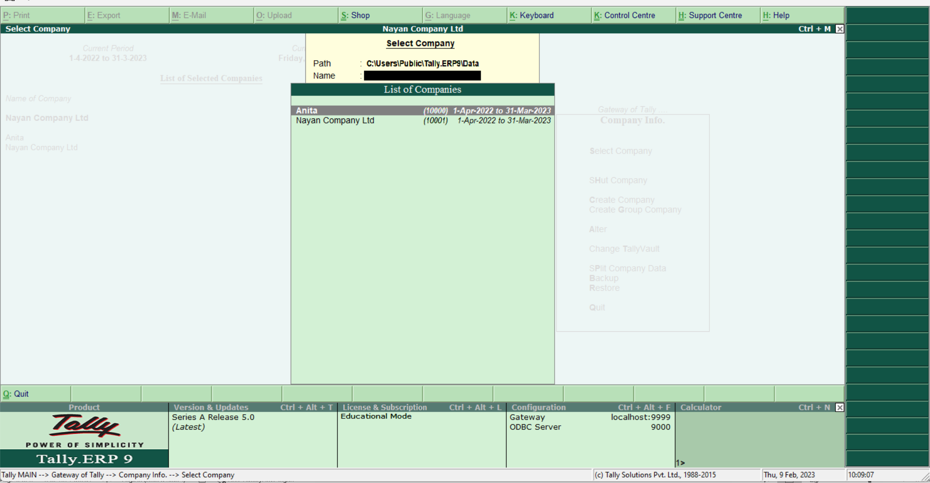

**Alter:** We can edit the information of companies created in Tally through use of alter.

* One can reach alter options, pressing (Alt+F3) in the gateway of tally. This option allows user to make modifications, change as per requirements to their company.

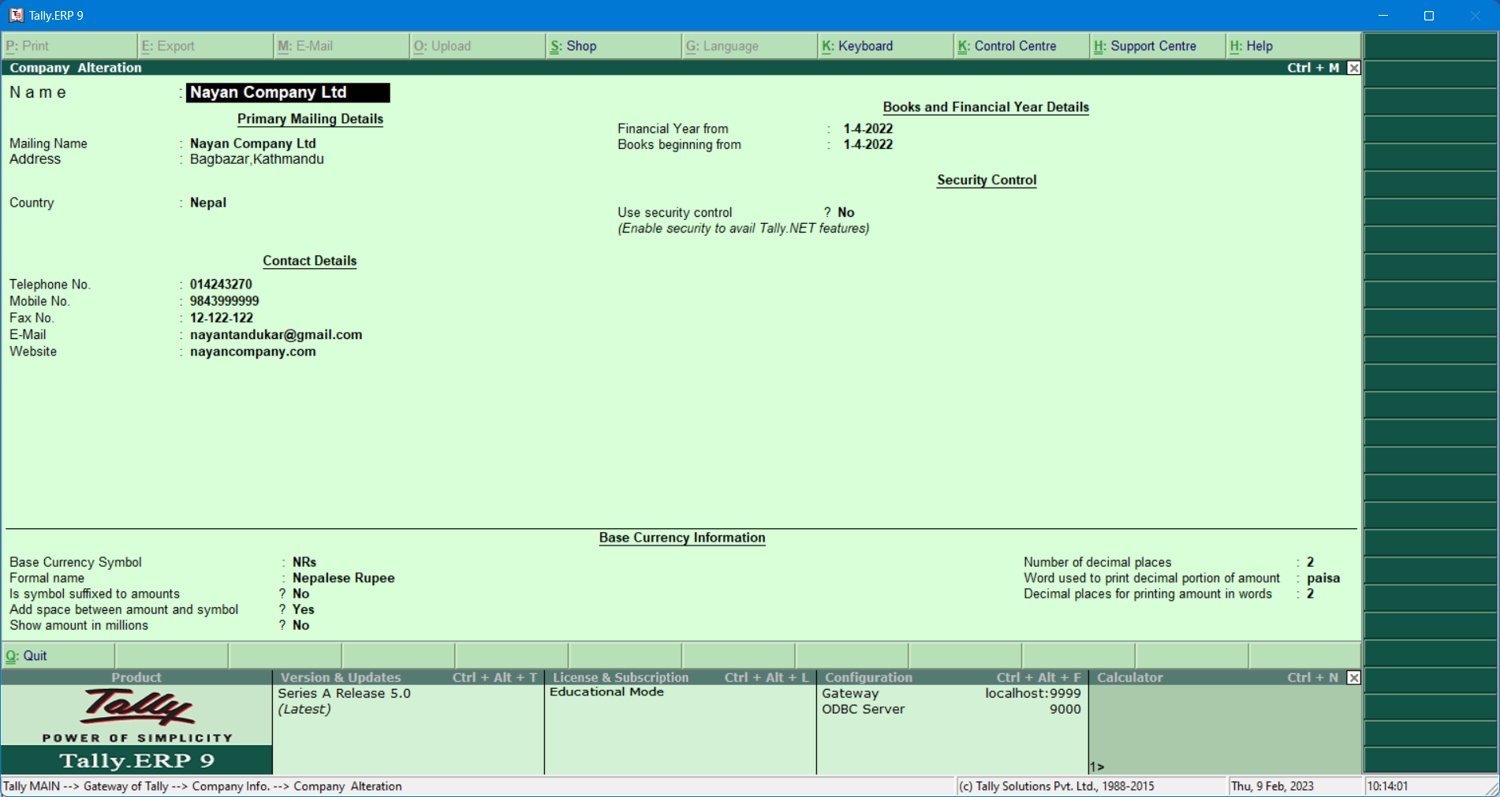

**Change Tally vault:** Tally vault is kind of security features built in Tally. It keeps up confidentially of information by encrypting the data. Combinations of such formulas help to ensure that Tally vault becomes one of the very most secure means of data storage. It also changes password of selected company.

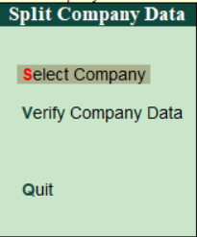**Split company data:** User can split company data into the time gaps by pressing (Alt+F3) in Gateway of tally and choosing split option. This splits company data into multiple numbers of years as per user demands. This increase flexibility in a accounting when data is split, companies are created for respective split periods and full of data is retained in the original company.

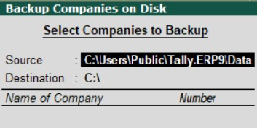**Backup:** Simplest way of reaching backup option is processing (Alt+F3) in gateway of tally. Backup is process of copying data from one location to other location. To avoid data lost on tally, one should take backup of tally data. Tally backup take on auto route to periodically safeguard business data from accidental loss, systems crash and even it to remote location.

**Restore:** This allows to restore data of companies for which backup is done. When current data is lost or corrupted, one can restores last backup data restores options in company info of tally.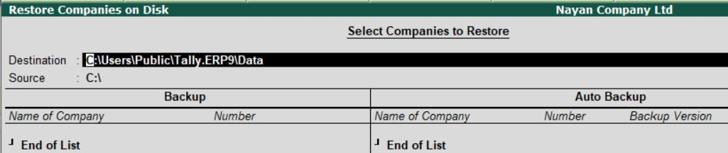

**Quit:** This option allows the user to close the tally windows pressing enter or ‘y’ in the keyboard.